**21.CREATE A USER-DEFINED RECORDS GENERATING CONSALIDATED MARKSHEET FROM STUDENT DETAIL (YOU CAN HAVE REQUISITE NUMBER OF TABLES ACCORDING TO YOUR USER DEFINED RECORDS AND REQUIREMENT APPLY INDEX BY TABLE OF RECORDS.**

**CREATE TABLE STUDENTS_DETAIL(STU_ID INT PRIMARY KEY,STU_NAME VARCHAR(20),STU_DEP VARCHAR(20),TOTAL_MARK INT,STU_GRADE VARCHAR(12));**

**INSERT INTO STUDENTS_DETAIL VALUES(1,'Ajith','IT',410,'A');**

**INSERT INTO STUDENTS_DETAIL VALUES(2,'Barani','AIML',452,'S');**

**INSERT INTO STUDENTS_DETAIL VALUES(3,'Dilli','CSE',347,'C');**

**INSERT INTO STUDENTS_DETAIL VALUES(4,'Elagovan','AI&DS',386,'B');**

**INSERT INTO STUDENTS_DETAIL VALUES(5,'Peter','IT',320,'C');**

**INSERT INTO STUDENTS_DETAIL VALUES(6,'Sarath','AIML',298,'D');**

**INSERT INTO STUDENTS_DETAIL VALUES(7,'Tamilselvan','ECE',478,'S');**

**INSERT INTO STUDENTS_DETAIL VALUES(8,'Wajith','EEE',367,'B');**

**INSERT INTO STUDENTS_DETAIL VALUES(9,'William','CSE',234,'FAIL');**

**INSERT INTO STUDENTS_DETAIL VALUES(10,'Weston','AI&DS',282,'D');**

**SELECT *FROM STUDENTS_DETAIL ORDER BY STU_ID;**

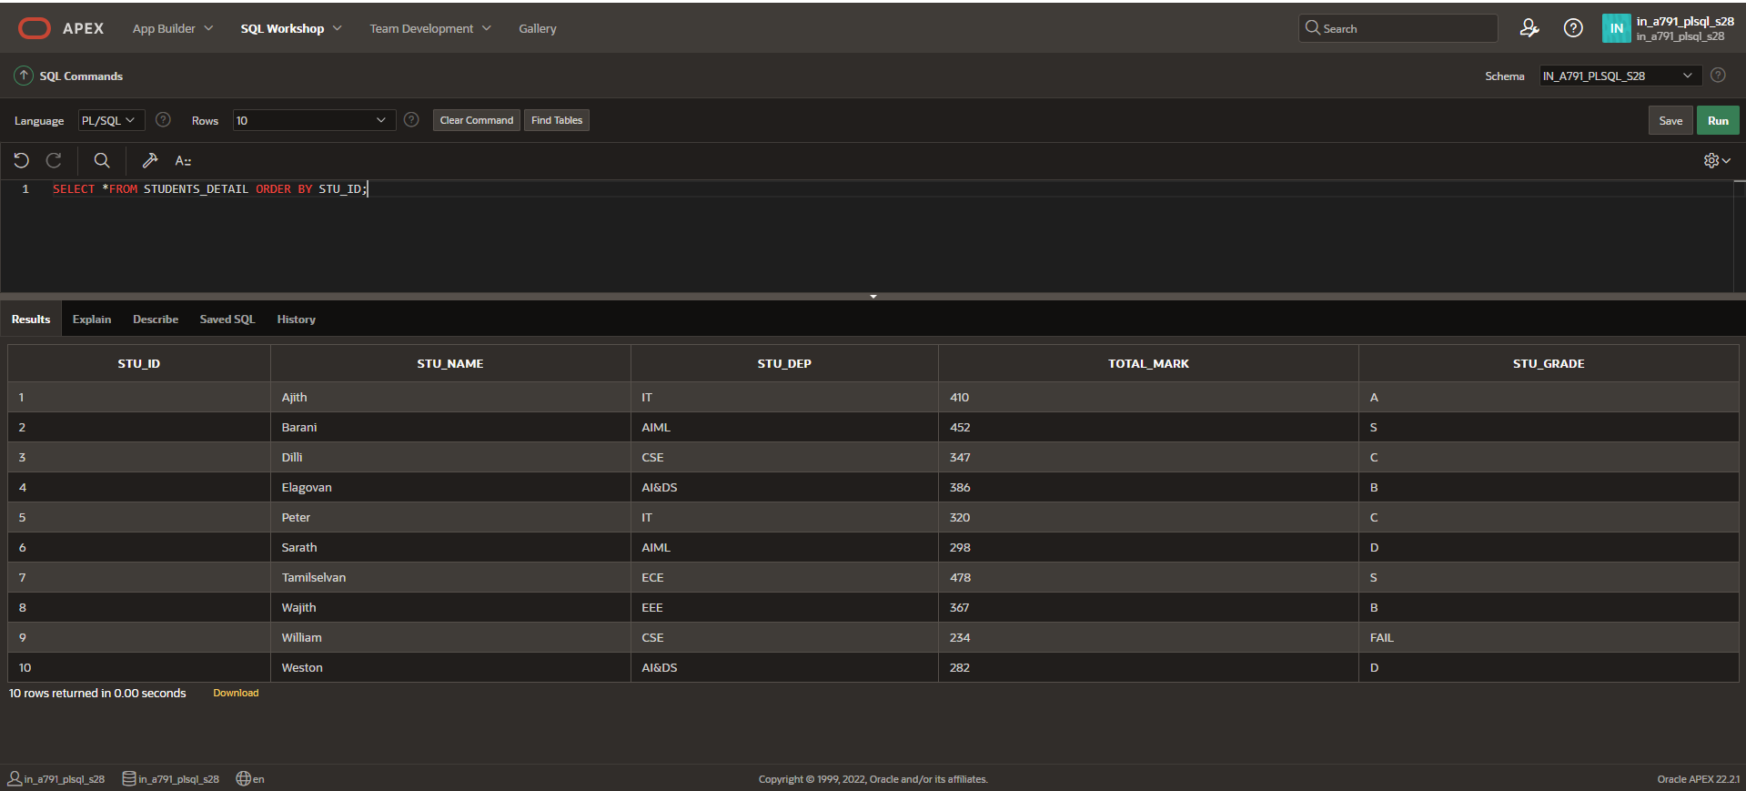

**USER-DEFINED RECORDS**

**DECLARE**

**TYPE STUDENT_DETAILS IS RECORD**

**(**

**STU_ID STUDENTS_DETAIL.STU_ID%TYPE,**

**STU_NAME STUDENTS_DETAIL.STU_NAME%TYPE,**

**TOTAL_MARK STUDENTS_DETAIL.TOTAL_MARK%TYPE,**

**STU_GRADE STUDENTS_DETAIL.STU_GRADE%TYPE**

**);**

**v_person_student_details STUDENT_DETAILS;**

**BEGIN**

**SELECT STU_ID,STU_NAME,TOTAL_MARK,STU_GRADE**

**INTO v_person_student_details**

**FROM STUDENTS_DETAIL**

**WHERE STU_ID = 8;**

**DBMS_OUTPUT.PUT_LINE('Student ID: '|| v_person_student_details.STU_ID || ',Name: ' || v_person_student_details.STU_NAME || ',Total Mark: ' || v_person_student_details.TOTAL_MARK || ',Grade: ' || v_person_student_details.STU_GRADE);**

**END;**

**/**

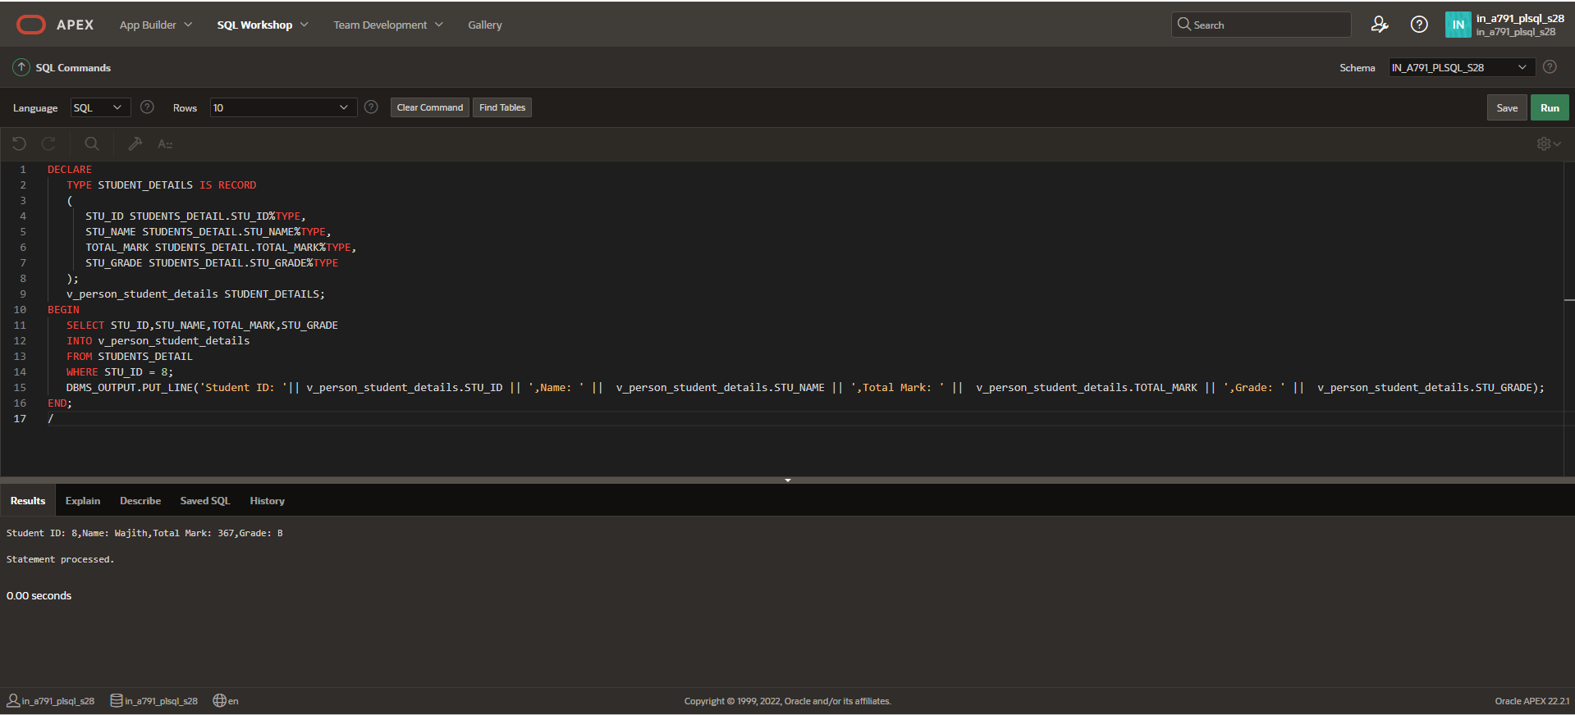

**INDEX BY TABLE OF RECORDS IN COUNT**

**DECLARE**

**TYPE stu_det IS TABLE OF STUDENTS_DETAIL.STU_GRADE%TYPE**

**INDEX BY VARCHAR(20);**

**v_stu_det_tab stu_det;**

**v_stu_det_count VARCHAR(20);**

**BEGIN**

**FOR stu_rec IN (SELECT STU_GRADE FROM STUDENTS_DETAIL)**

**LOOP**

**v_stu_det_tab(stu_rec.STU_GRADE):=stu_rec.STU_GRADE;**

**END LOOP;**

**DBMS_OUTPUT.PUT_LINE(v_stu_det_tab.COUNT);**

**END;**

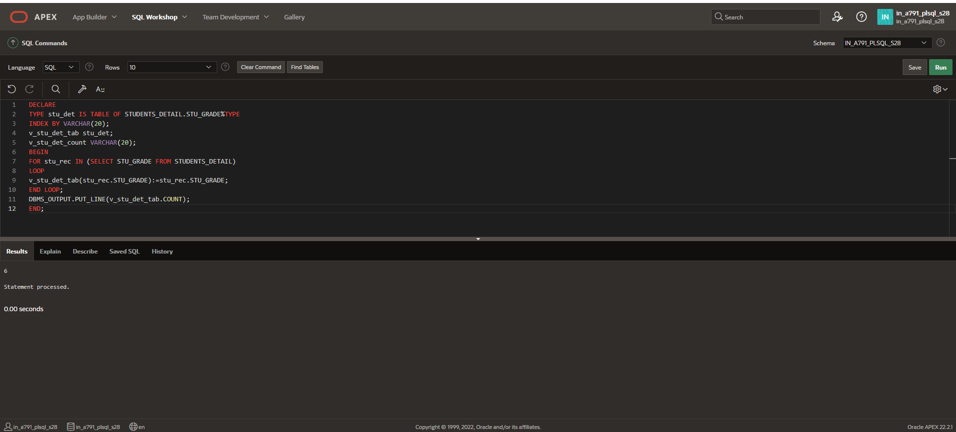

**INDEX BY TABLE OF RECORDS IN FIRST**

**DECLARE**

**TYPE stu_det IS TABLE OF STUDENTS_DETAIL.STU_GRADE%TYPE**

**INDEX BY VARCHAR(20);**

**v_stu_det_tab stu_det;**

**v_stu_det_count VARCHAR(20);**

**BEGIN**

**FOR stu_rec IN (SELECT STU_GRADE FROM STUDENTS_DETAIL)**

**LOOP**

**v_stu_det_tab(stu_rec.STU_GRADE):=stu_rec.STU_GRADE;**

**END LOOP;**

**DBMS_OUTPUT.PUT_LINE(v_stu_det_tab.FIRST);**

**END;**

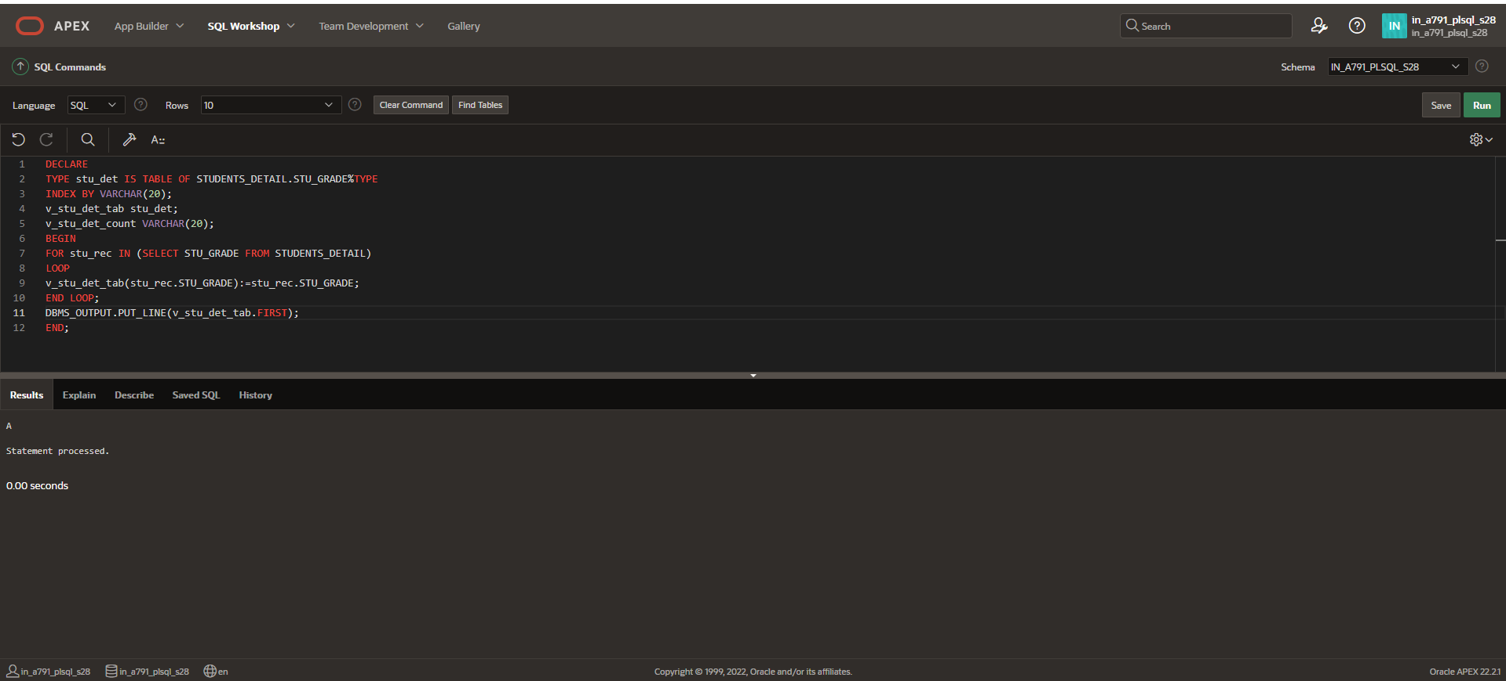

**INDEX BY TABLE OF RECORDS IN LAST**

**DECLARE**

**TYPE stu_det IS TABLE OF STUDENTS_DETAIL.STU_GRADE%TYPE**

**INDEX BY VARCHAR(20);**

**v_stu_det_tab stu_det;**

**v_stu_det_count VARCHAR(20);**

**BEGIN**

**FOR stu_rec IN (SELECT STU_GRADE FROM STUDENTS_DETAIL)**

**LOOP**

**v_stu_det_tab(stu_rec.STU_GRADE):=stu_rec.STU_GRADE;**

**END LOOP;**

**DBMS_OUTPUT.PUT_LINE(v_stu_det_tab.LAST);**

**END;**

